

Faculty of Engineering (Degree)
Semester – 1
Subject Name – Programming for Problem Solving
Subject Code - BE100109
Faculty Name – Ashwini Walake
Unit - 10: File Handling

File Handling
File handling is the process of storing, reading, and writing data to and from files permanently on a storage device, rather than just in a computer's memory. It allows programs to persist data, process large datasets, automate tasks, and access external data like configuration files or user input, providing a way to manage the flow of information between a program and the file system.
File handling in C is the process in which we create, open, read, write, and close operations on a file. C language provides different functions such as fopen(), fwrite(), fread(), fseek(), fprintf(), etc. to perform input, output, and many different C file operations in our program.

Types of Files
Files are generally categorized into two main groups based on how data is encoded and stored on the storage device:
- Text Files (.txt, .c, etc.): These files store data as standard human-readable ASCII or Unicode characters. They use special end-of-line markers (like \n) to separate lines of text.
- Binary Files (.dat, .bin, etc.): These files store data in raw bytes (0s and 1s), exactly as it is represented in the computer's primary memory. They are more compact and efficient for storing structured data like arrays and structs

C File Operations
C language provides the following different operations that we can perform on a file from our C program:
- Creating a new file.
- Opening an existing file.
- Reading from file.
- Writing to a file.
- Moving to a specific location in a file.
- Closing a file.
Open a File in C
For opening a file in C, the fopen() function is used with the filename or file path along with the required access modes.
Syntax:
FILE* fopen(*file_name, *access_mode);
Parameters
- file_name: name of the file when present in the same directory as the source file. Otherwise, full path.
- access_mode: Specifies for what operation the file is being opened.
Return Value
- If the file is opened successfully, returns a file pointer to it.
- If the file is not opened, then returns NULL.

File Opening Modes
File opening modes or access modes specify the allowed operations on the file to be opened. They are passed as an argument to the fopen() function. Some of the commonly used file access modes are listed below:
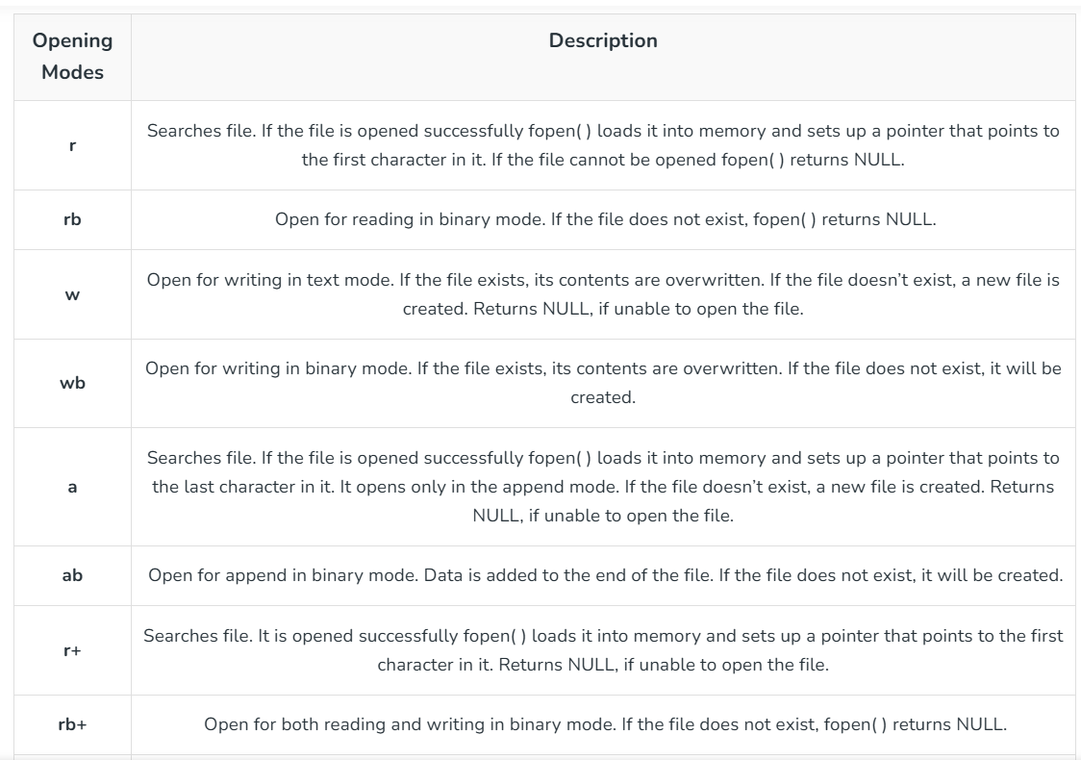
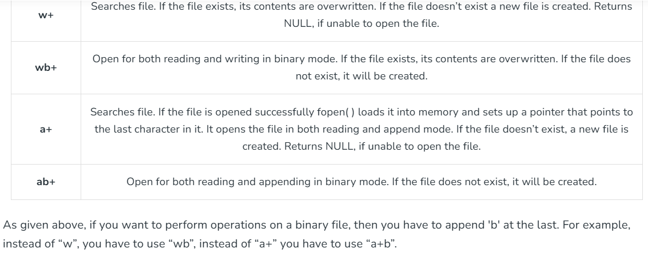
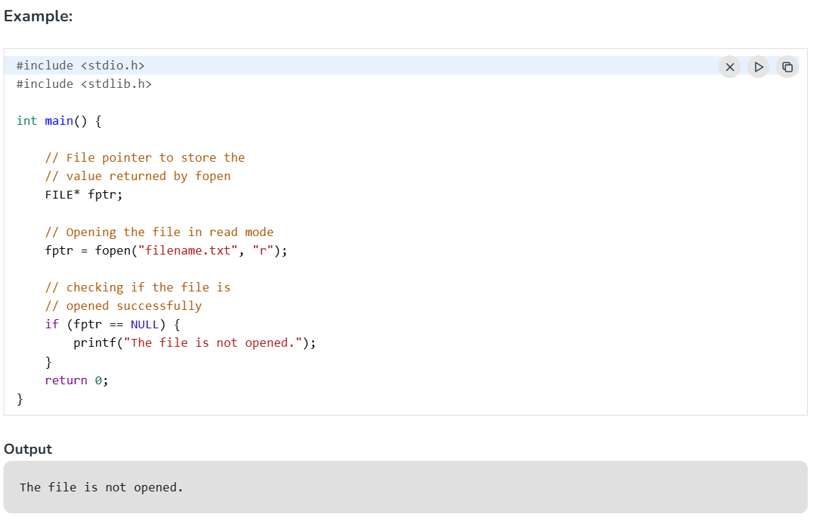
The file is not opened because it does not exist in the source directory. But the fopen() function is also capable of creating a file if it does not exist.
Note: If is essential to check for NULL values that might be returned by the fopen() function to avoid any errors.
Create a File
The fopen() function can not only open a file but also can create a file if it does not exist already. For that, we have to use the modes that allow the creation of a file if not found such as w, w+, wb, wb+, a, a+, ab, and ab+.
Example:
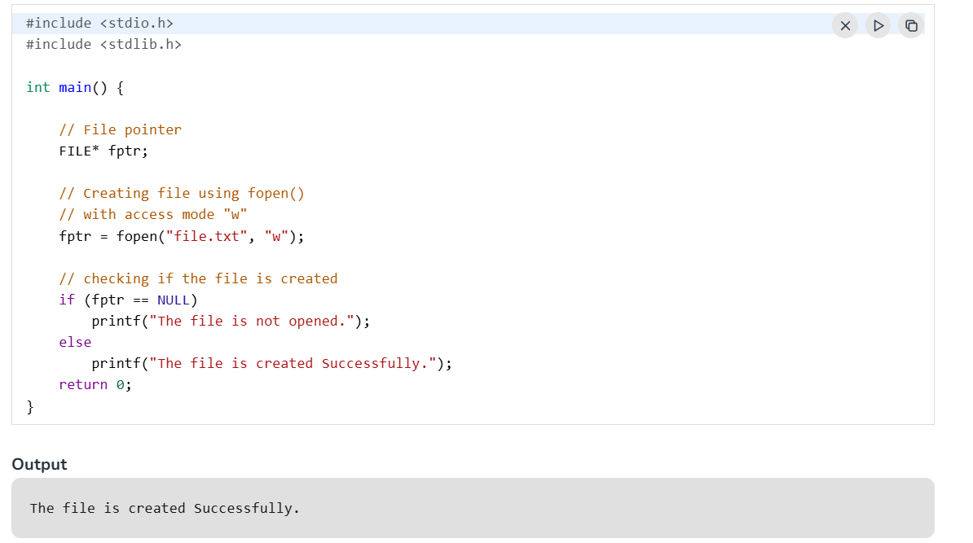
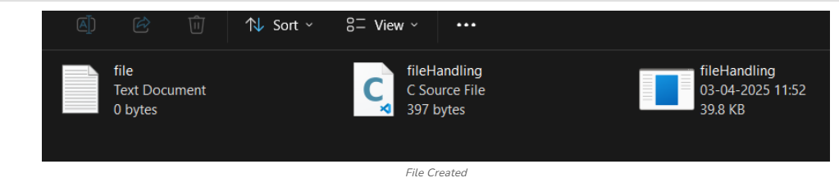
Write to a File
The file write operations can be performed by the functions fprintf() and fputs(). C programming also provides some other functions that can be used to write data to a file such as:
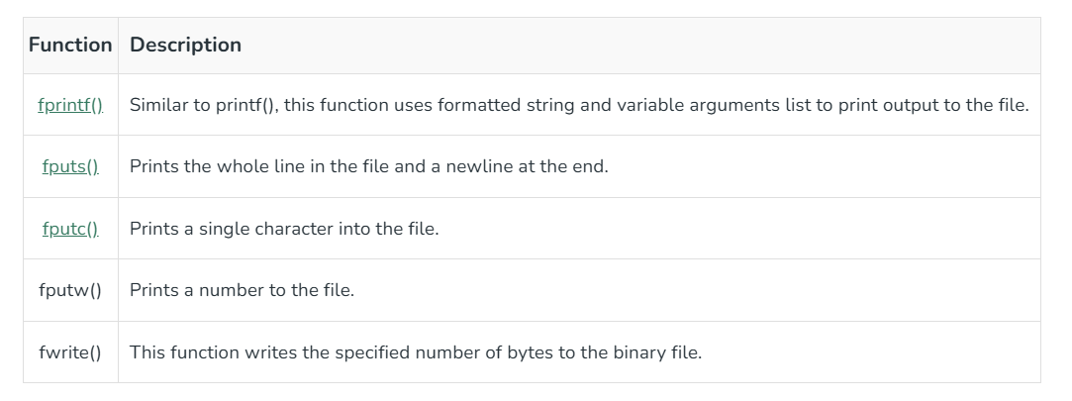
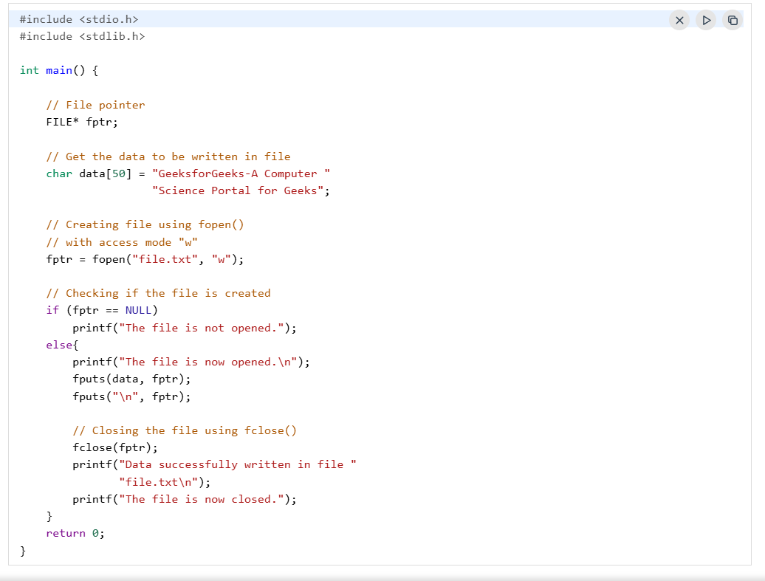
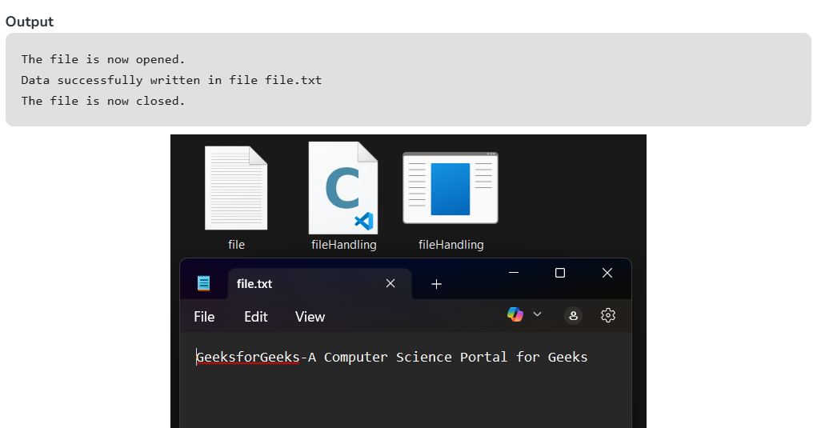
Reading From a File
The file read operation in C can be performed using functions fscanf() or fgets(). Both the functions performed the same operations as that of scanf() and gets but with an additional parameter, the file pointer. There are also other functions we can use to read from a file. Such functions are listed below:
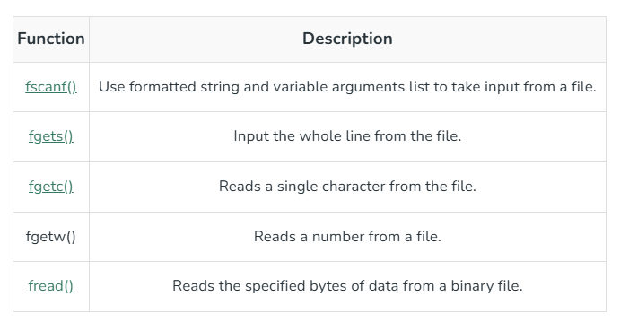
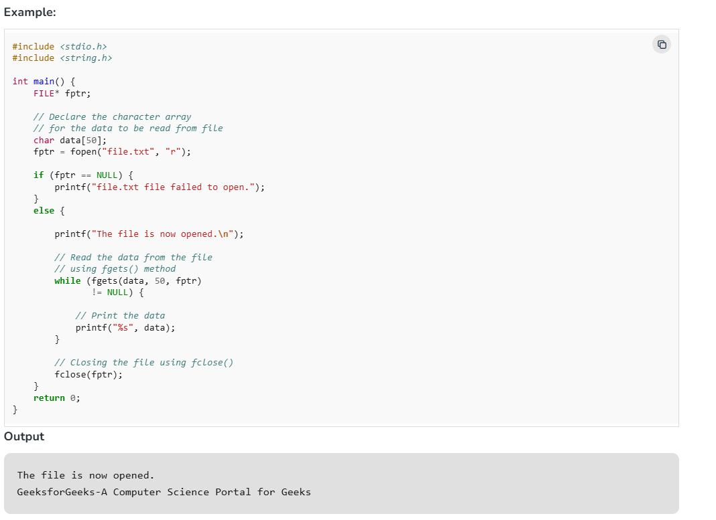
The getc() and some other file reading functions return EOF (End Of File) when they reach the end of the file while reading. EOF indicates the end of the file, and its value is implementation-defined. Reading more after EOF results in undefined error so, it is always recommended to check for EOF while reading a file.
Note: One thing to note here is that after reading a particular part of the file, the file pointer will be automatically moved to the end of the last read character.
Closing a File
The fclose() function is used to close the file. After successful file operations, you must always close a file to remove it from the memory.
Syntax:
fclose(file_pointer);
Move File Pointer
File pointer generally points to the position according to the mode or last read/write operation. We can manually move this pointer to any position in the file using fseek() function.
Syntax:
fseek(fptr, offset, pos);
where, pos is the position from where offset is counted and offset is the number of positions to shift from pos (it can be negative or positive).
Example:
While writing to a file opened in rw+ mode, the file pointer moves to the end of the file. In case where we want to replace a word, then first we have to move the file pointer to the position where that word starts.
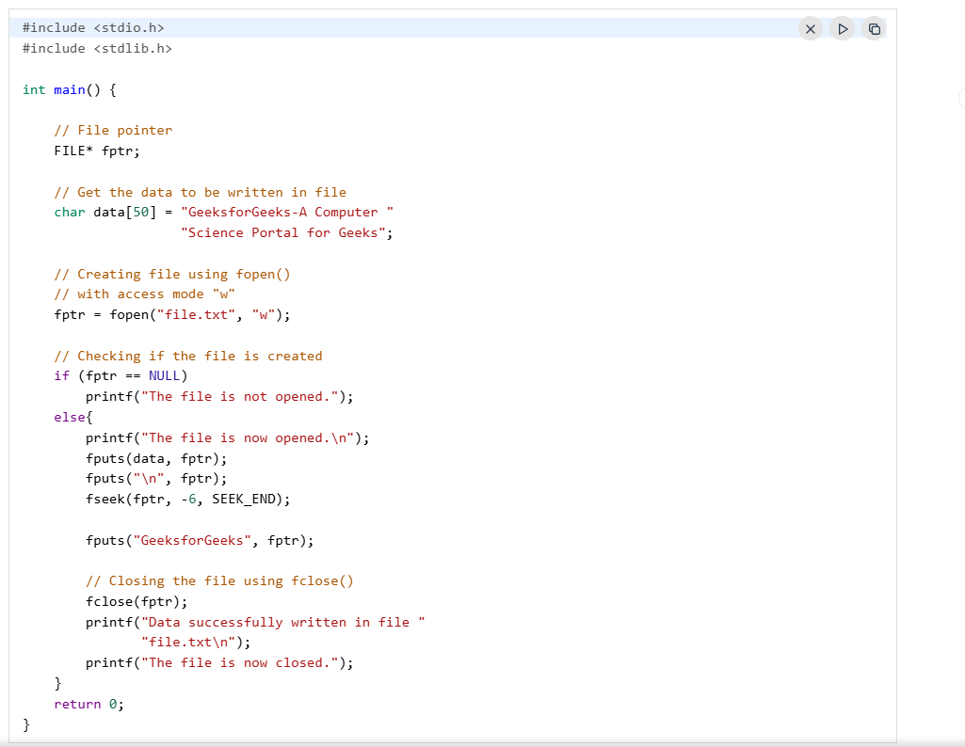
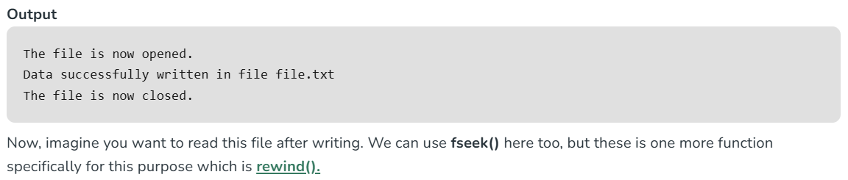
Read and Write in a Binary File
Till now, we have only discussed text file operations. The operations on a binary file are similar to text file operations with little difference.
Opening a Binary File
To open a file in binary mode, we use the rb, rb+, ab, ab+, wb, and wb+ access mode in the fopen() function. We also use the .bin file extension in the binary filename.
Example:
fptr = fopen("filename.bin", "rb");
Write to a Binary File
We use fwrite() function to write data to a binary file. The data is written to the binary file in the form of bits (0's and 1's).
Syntax of fwrite()
fwrite(ptr, size, nmemb, file_pointer);
Parameters:
- ptr: pointer to the block of memory to be written.
- size: size of each element to be written (in bytes).
- nmemb: number of elements.
- file_pointer: FILE pointer to the output file stream.
Return Value:
- Number of objects written.
Example: Program to write to a Binary file using fwrite()

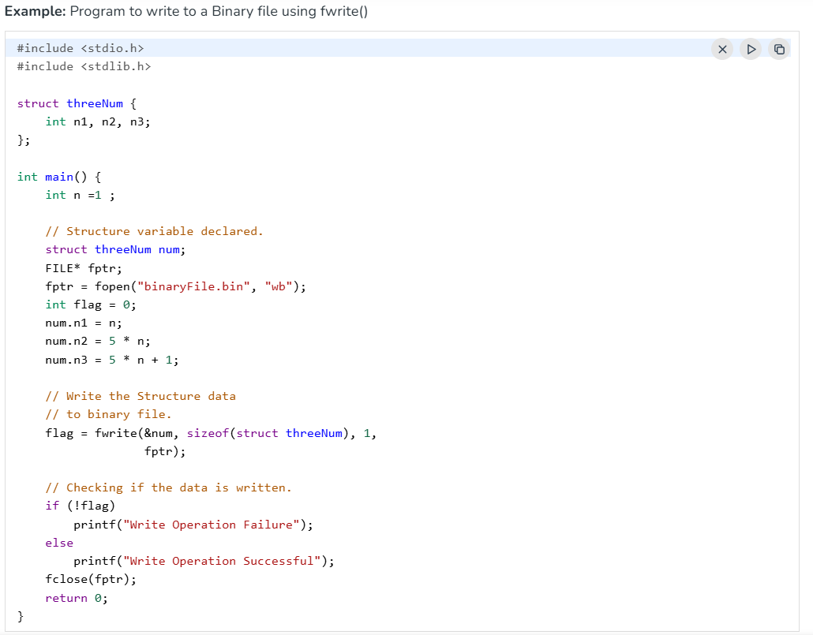
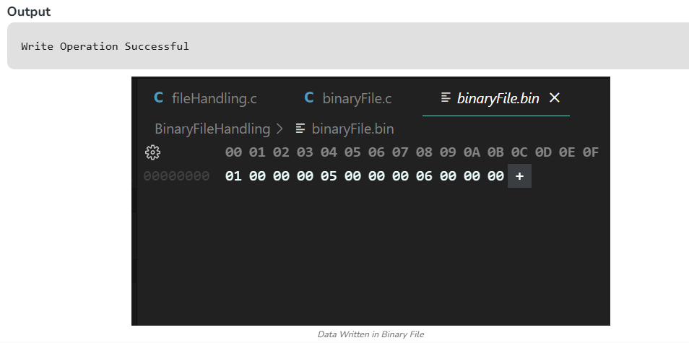
Reading from Binary File
The fread() function can be used to read data from a binary file in C. The data is read from the file in the same form as it is stored i.e. binary form.
Syntax:
fread(ptr, size, nmemb, file_pointer);
Parameters:
- ptr: pointer to the block of memory to read.
- size: the size of each element to read (in bytes).
- nmemb: number of elements.
- file_pointer: FILE pointer to the input file stream.
Return Value:
- Number of objects read.
